LAB 10

->threads and synchronization mechanisms

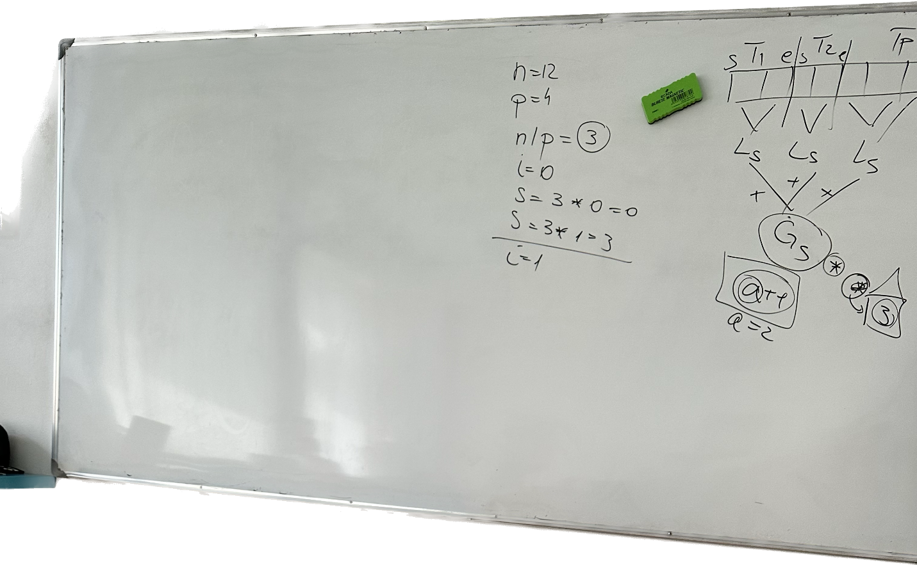

* For the exam: mutexes, read write locks, barriers
* Decide to use whatever you want, but if we want to get the optimal way: read write locks

->mutex example

->barriers

->read write lock

->compile

->output